Name: Shaikh Shahbaz
Linux commands 42-tasks :

1.Create user with name techie and provide sudo access to user.
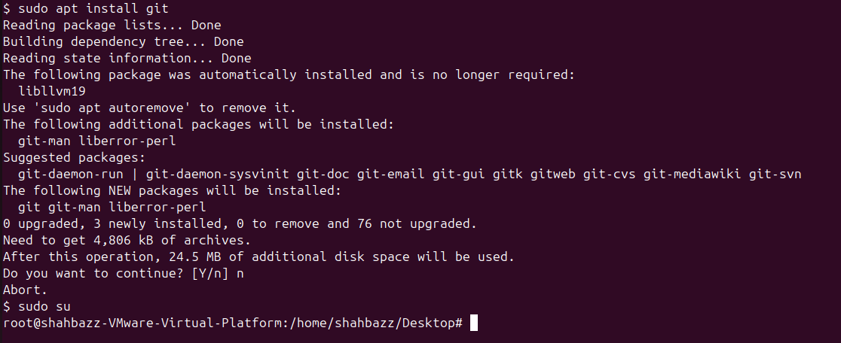
Commands used:
a).Command to create new user: useradd techie
b).Command to create password for new user: passwd techie
c).Command to check user has got sudo access is : apt install git

2.Navigate to the home directory.
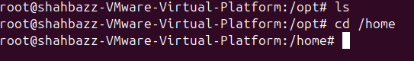
The home directory is present only in root directory.
Command : cd /home

3.Create a new directory.
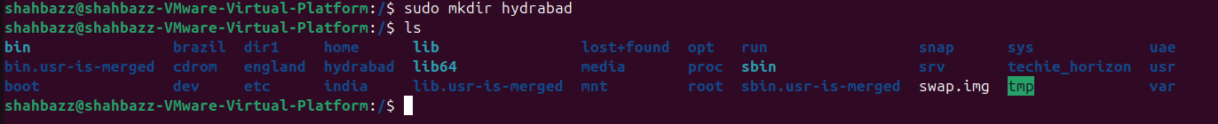
Command : mkdir Hyderabad

4.List the contents of the directory.
Command : ls

5.Change the current directory.
Command : cd /etc

6.Create a new empty file.
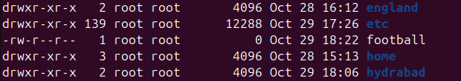
Football is an empty file with size 0 byts.
Command : touch football

7.View the contents of a file.
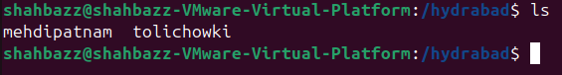
hydrabad is a file and mehdipatnam and tolichowki are the contents .
change directory to hydrabad using : cd hydrabad/ , then add the contents to it.
Command : ls

8.Copy a file to another location.
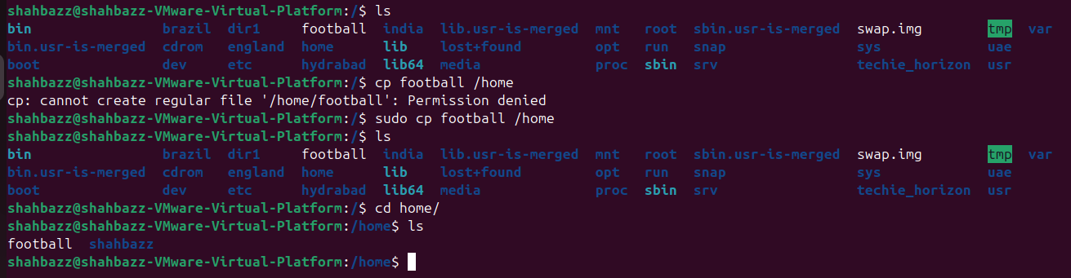
Copying a file named football from its actual location to another location which is home.
Command : cp football/

9.Move a file to another location.
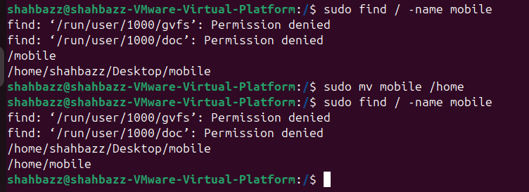
The file name mobile is moved from one location to another location.
Command : mv mobile /home

10.Rename a file.
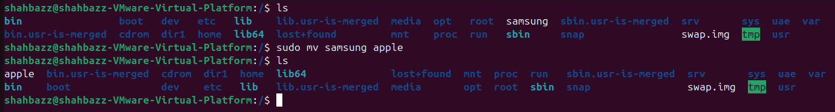
Renamed the file from Samsung to apple .
Command : mv samsung apple

11.Delete a file.
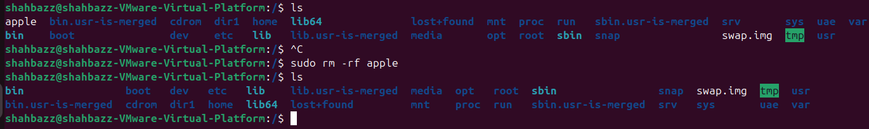
File named apple is deleted.
Command : rm -rf apple

12. Grant or revoke permissions on a file or directory.
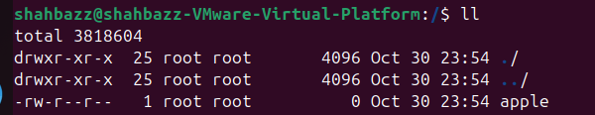
File name apple before allowing permissions.
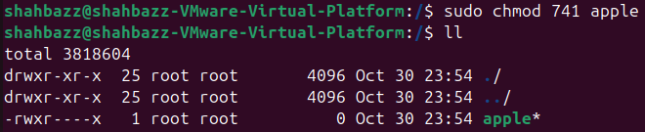
File name apple after allowing permissions like –
User : read access
Group : read,write and execute access
Other : execute access.
Command : chmod 741 apple

13.View the current date and time.
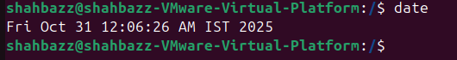
Command : date

14. Check the system uptime.
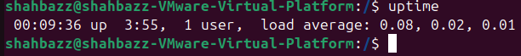
Command : uptime

15. View the running processes.
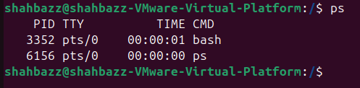
Command : ps

16. Kill a running process.
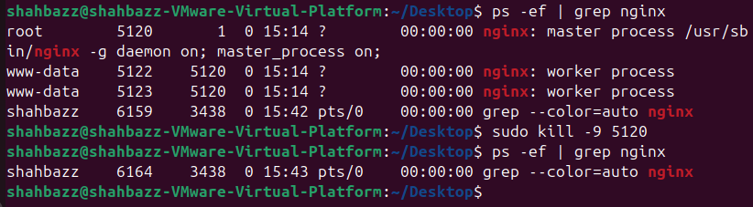
Command : kill -9 5120 ---(root id)

17. Install a package using the package manager (e.g., apt or yum)
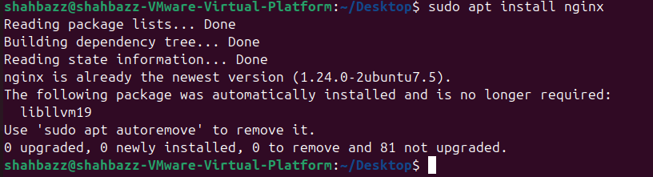
Command : apt install ngnix
apt : package manager for ubuntu

18. Update the system packages.
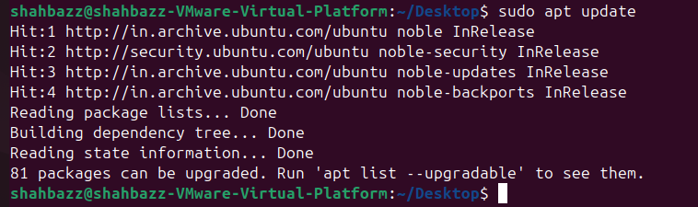
Command : sudo apt update

19. Create a symbolic link.
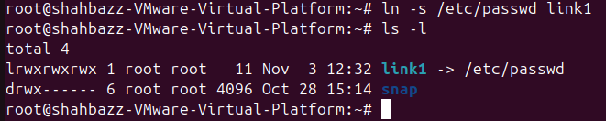
We have created the link for password
Command : ln -s /etc/passwd link1

Now if we have to see /etc/passwd file , now simply we have to type
Cat link1 it will show all passwords
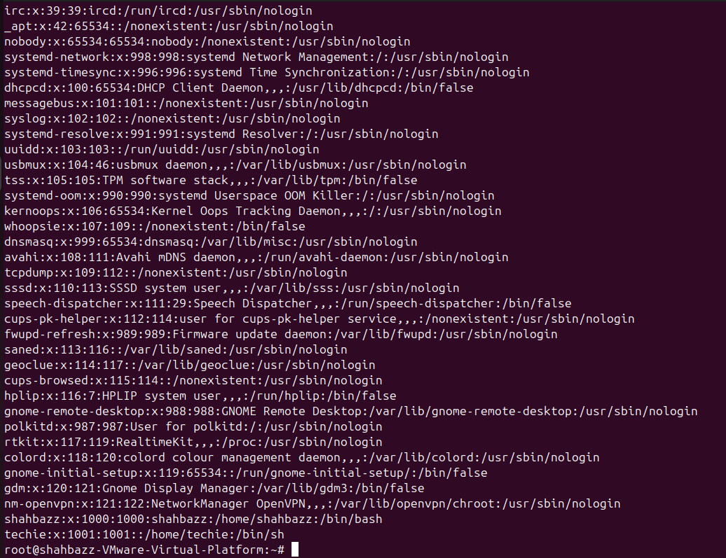
To delete the symbolic link
Command : rm link1
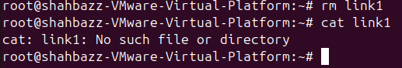

20. Search for files using the find command.
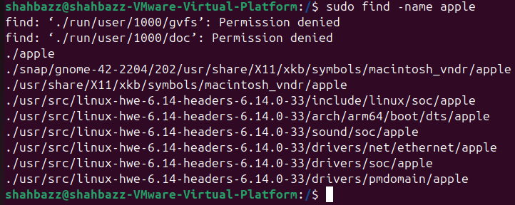
File named apple is searched .
Command : find -name apple

21. Compress and decompress files using tar.
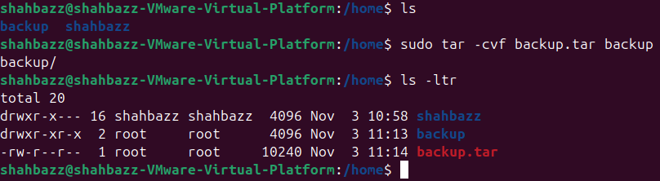
To compress file using tar
Command : tar -cvf backup.tar backup

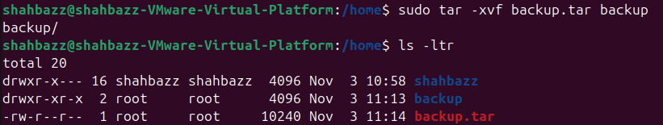
To Decompress file using tar
Command : tar -xvf backup.tar backup
22. Monitor system resources with top or htop.
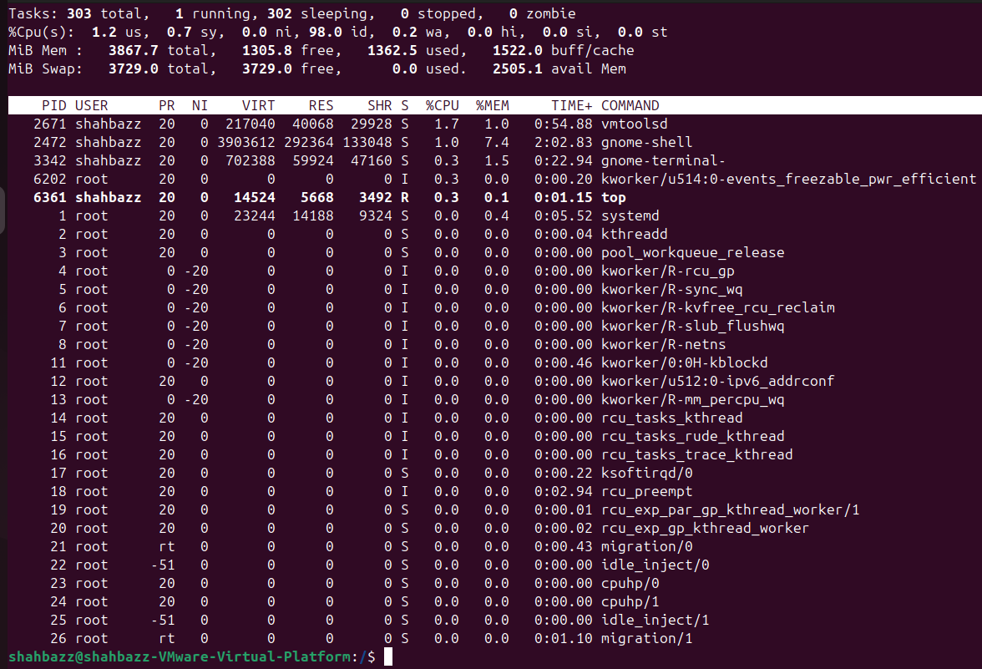
Command : top

23. Create and manage user groups.
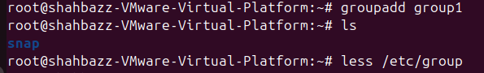
To create user group
Command : groupadd group1
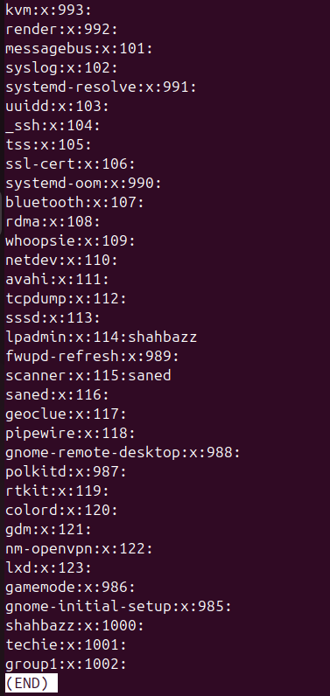
To see the group created
Command : less /etc/group
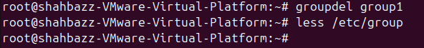
To delete the user group
Command : groupdel group1

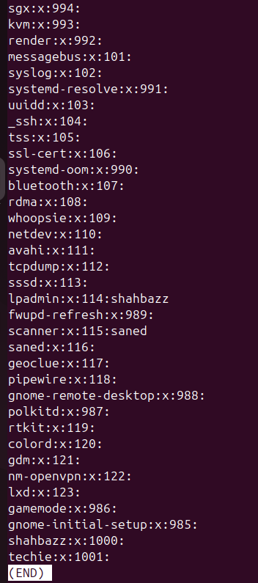
Here we can see that the group1 is deleted

25. Monitor log files using tail or grep.
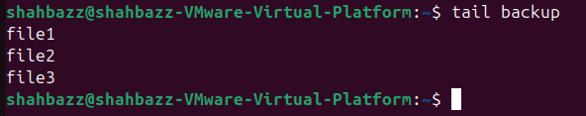
To see the last lines in a file we use tail command
Command : tail backup
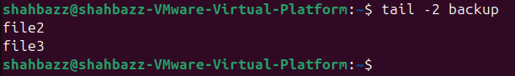
To see last 2 lines in a file we use
Command : tail -2 backup
To check specific keyword in a file we use grep command
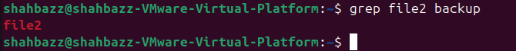
Command : grep file2 backup
26. Set up a web server (e.g., Apache or Nginx).
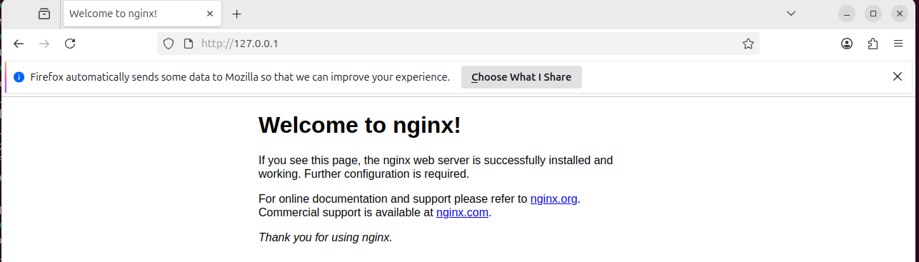
First we need to install nginx by using apt install command
After the status is running then we should check public ip
Command : ip a
Then we should paste the public ip in firefox browser.

30. Print specific columns from a delimited file.
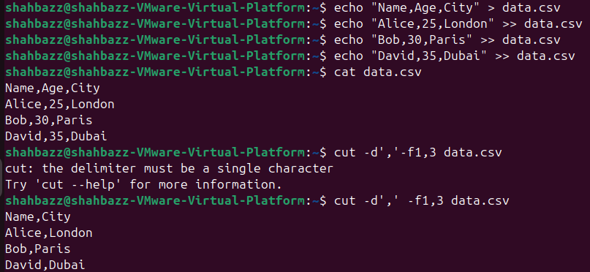
To print specific columns from a file
Command : cut -d’,’ -f1,3 data.csv

31. Filter and print lines based on a specific pattern or condition.
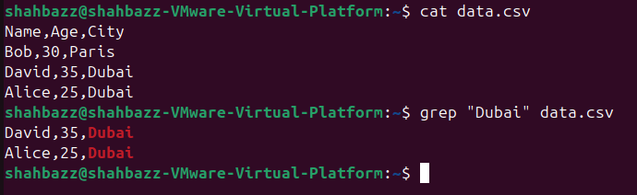
To filter and print lines based on a specific pattern or condition
Command : grep “Dubai” data.csv

32. Calculate and print the average, sum, or other statistics of a column.
Average and Sum :
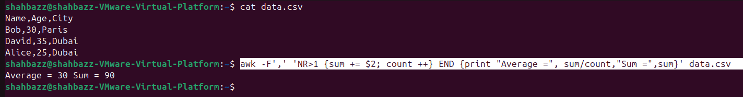
Command : awk -F',' 'NR>1 {sum += $2; count ++} END {print "Average =", sum/count,"Sum =",sum}' data.csv

34. Count the occurrences of a specific pattern in a file.
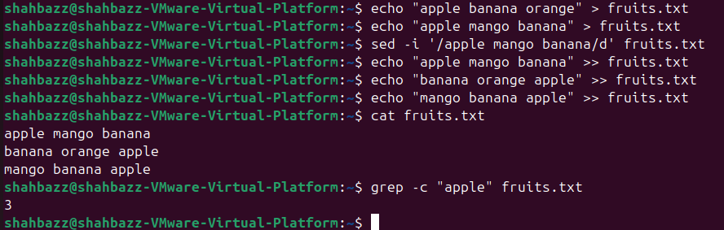
Command : grep -c “apple” fruits.txt

35. Sort lines based on a specific field or column.
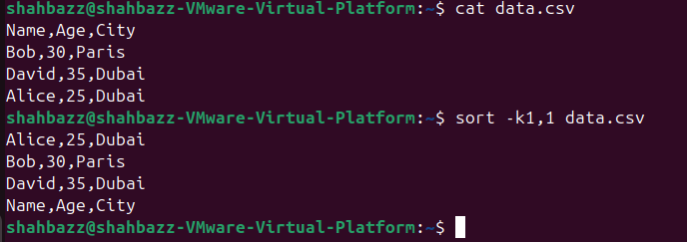
Sort alphabetically by the first column [Name]
Command : sort -k1,1 data.csv

36. Merge multiple files based on a common field or column.
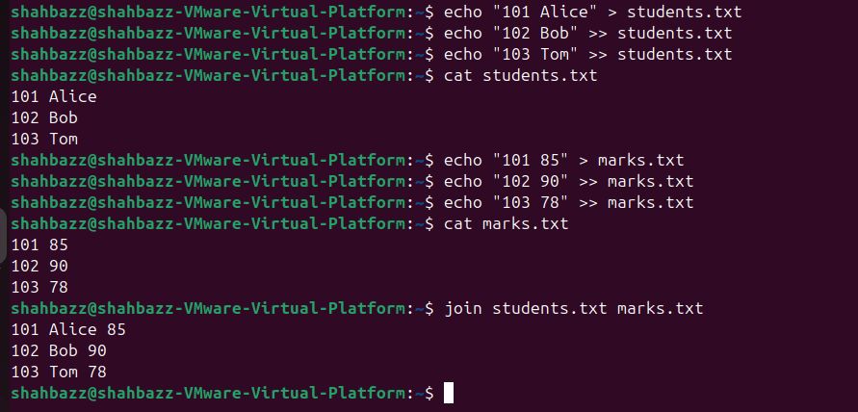
Command : join students.txt marks.txt

37. Substitute text in a file using search and replace.
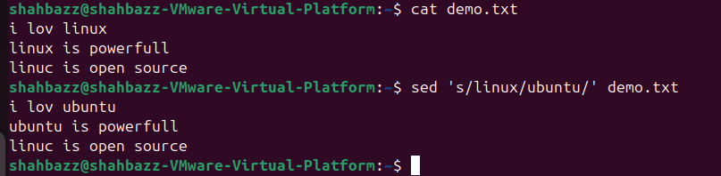
Command : sed ‘s/linux/ubuntu/’ demo.txt

38. Delete specific lines based on a pattern or line number.
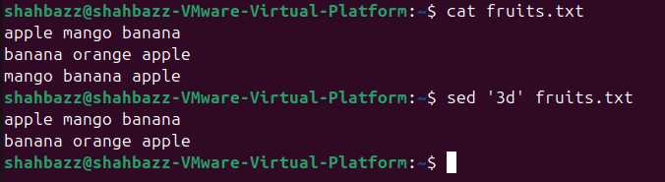
Command : sed ‘3d’ fruits.txt

39. Append or insert text before or after a specific pattern or line.
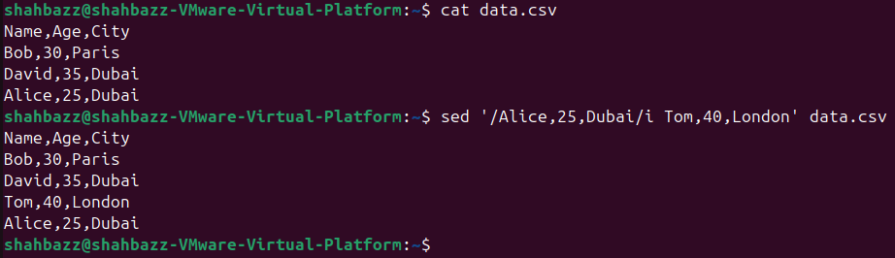

40. Print only specific lines from a file.
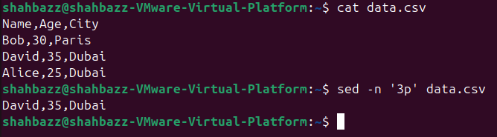
Command : sed -n ‘3p’ data.csv

42. use cases for AWK and 5 use cases for sed
Awk : used cases
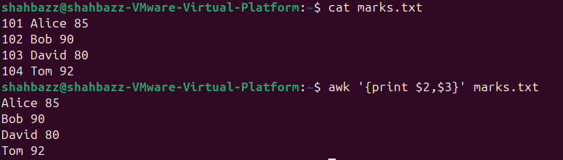
To Print specific columns
Command : awk ‘{print $2,$3}’ marks.txt

To calculate the sum and average of a column
Command : awk -F',' 'NR>1 {sum += $2; count ++} END {print "Average =", sum/count,"Sum =",sum}' data.csv

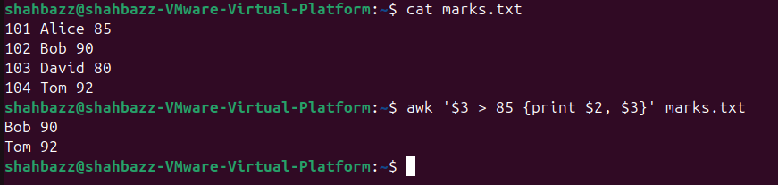
Filter the lines based on condition
Command : awk '$3 > 85 {print $2, $3}' marks.txt

Sed use case :

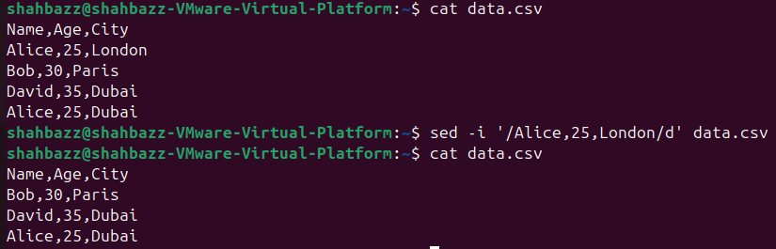
To remove or delete a specific line from the file
Command : sed -I ‘/Alice,25,London/d’ data.csv

To insert a text before or after a specific line in a file
Command : sed ‘/Alice,25,Dubai/i Tom,40,London’ data.csv

To print a specific line to the file
Command : sed -n ‘3p’ data.csv

